**ASSIGNMENT – 1**

**Q1. What is software ? What is software engineering?**

* Software is a collection of instructions, data, or computer programs that are used to run machines and perform particular activities.
* In a computer system, the software is basically a set of instructions or commands that tell a computer what to do and how to do.
* Software engineering is the process of designing, developing, testing, and maintaining software.
* Software engineering is an art of developing quality software on the time within budget.
* principles of Software Engineering:

1) Efficiency

2) Reliability

3) Usability

4) Maintainability

5) Portability

**Q2) Explain types of software**

* System Software: This type of software directly operates the computer hardware and provides the basic functionality to the users as well as to the other software to operate smoothly. It includes the operating system and device drivers.
* Application Software: These are programs designed to perform specific tasks for users. Examples include word processors, spreadsheets, and web browsers.
* Operating System: This is the main program of a computer system that manages all the resources such as computer memory, CPU, printer, hard disk, etc., and provides an interface to the user.
* Device Driver: A device driver is a program or software that controls a device and helps that device to perform its functions.
* Language Processor: This type of software converts programs written in high-level programming languages into sets of instructions that are easily readable by machines

**Q3) What is SDLC? Explain each phase of SDLC.**

* SDLC – Software Development Life Cycle.
* It's a structured process used by software developers to design, develop, test, and deploy software applications. The SDLC involves a series of phases that guide the development process from the initial planning stages to the final deployment and maintenance of the software. These phases typically include:
* 1. Requirements gathering: Defining the scope, objectives, and requirements of the project.
* 2. Analysis: Gathering and analysing requirements from stakeholders to understand what the software needs to accomplish.
* 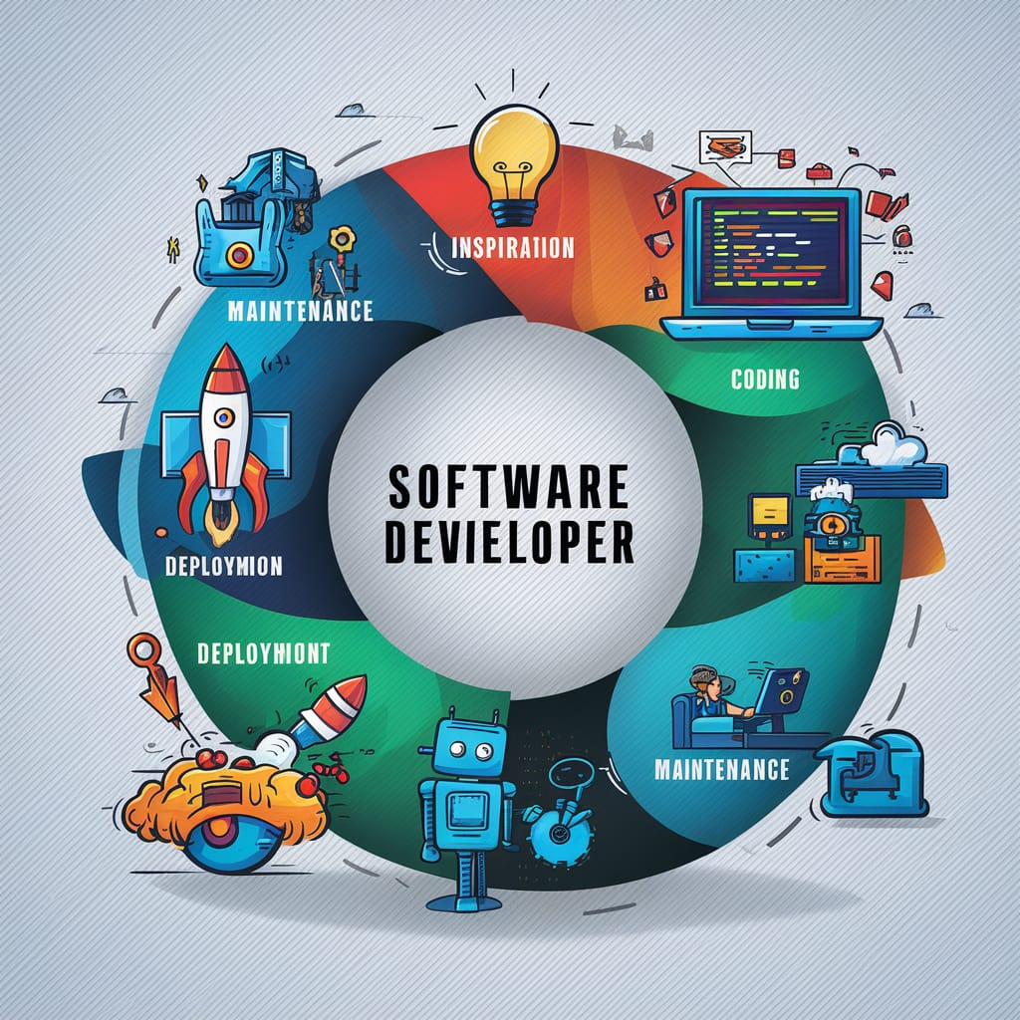
* 3. Design: Creating a blueprint for how the software will be structured and how its components will interact.
* 4. Implementation: Writing the code and building the software according to the design specifications.
* 5. Testing: Verifying that the software functions correctly and meets the specified requirements through various testing methods.
* 6. Maintenance: Providing ongoing support, updates, and enhancements to ensure the software remains functional and efficient throughout its lifecycle.
* The SDLC helps ensure that software projects are completed on time, within budget, and with high quality. It provides a framework for managing and controlling the development process, allowing developers to systematically move from one phase to the next while mitigating risks and addressing any issues that arise along the way.

**Q.4) what is DFD? Give Flipkart DFD diagram**.

Data Flow Diagram (DFD) is a graphical tool used to represent the flow of data within a system or process. It provides insight into the inputs, outputs, and transformations associated with each entity and process. Here are some key points about DFDs:

Purpose of DFDs:-

DFDs help visualize how data moves through a system or process.

They are useful for communicating with users, managers, and other personnel.

DFDs aid in analysing existing and proposed systems.

It’s help to under stand how to actual data flow in the computer system.

Advantages of DFDs:

Capture transformations within a system.

Hierarchically organize large systems.

Provide an overview of data flow, transformations, storage, and results.

In DFD there are mainly three level

1. 0 level
2. 1 level
3. 2 level
4. 3 level

* **Level 0:-** is also called a Context Diagram. It’s a basic overview of the whole system or process being analyzed or modeled. It’s designed to be an at-a-glance view, showing the system as a single high-level process, with its relationship to external entities. It should be easily understood by a wide audience, including stakeholders, business analysts, data analysts and developers.
* 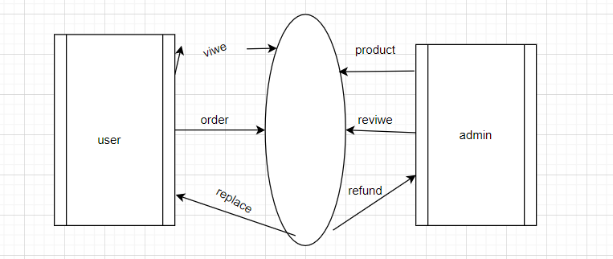

**Level 1:-** Level 1 provides a more detailed breakout of pieces of the Context Level Diagram. You will highlight the main functions carried out by the system, as you break down the high-level process of the Context Diagram into its subprocesses. 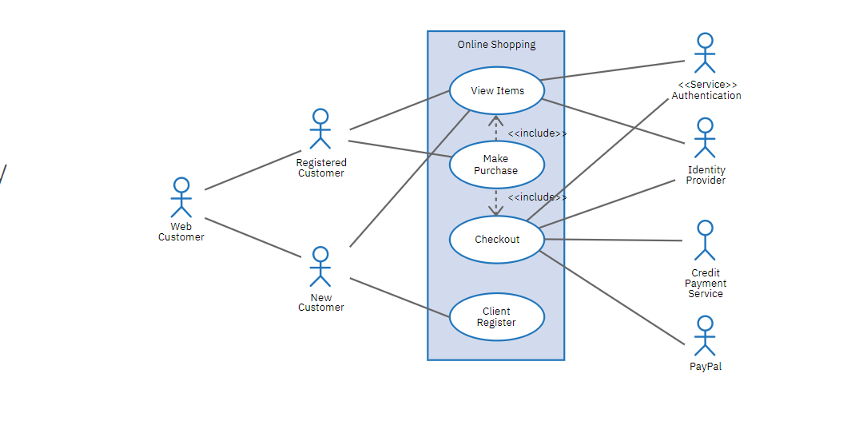

**Level 2**:- then goes one step deeper into parts of Level 1. It may require more text to reach the necessary level of detail about the system’s functioning.Progression to Levels 3 beyond is possible, but going beyond Level 3 is uncommon. Doing so can create complexity that makes it difficult to communicate, compare or model effectively.

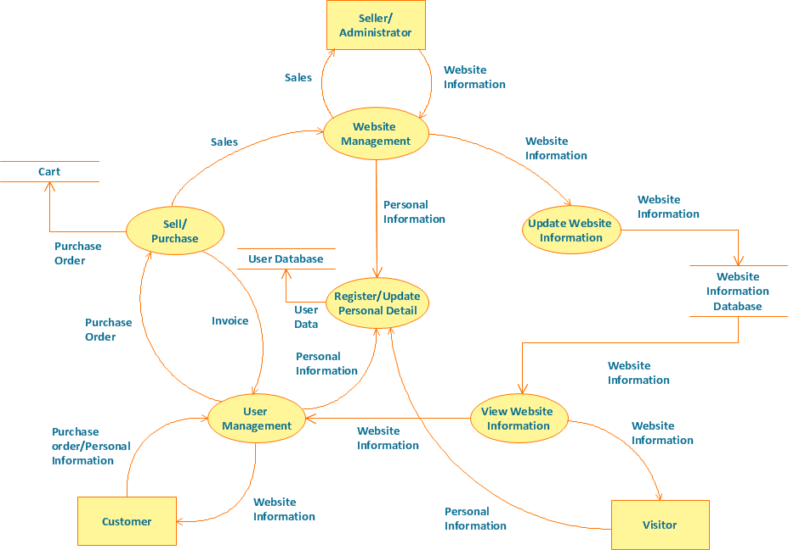

(Online shopping DFD diagram)

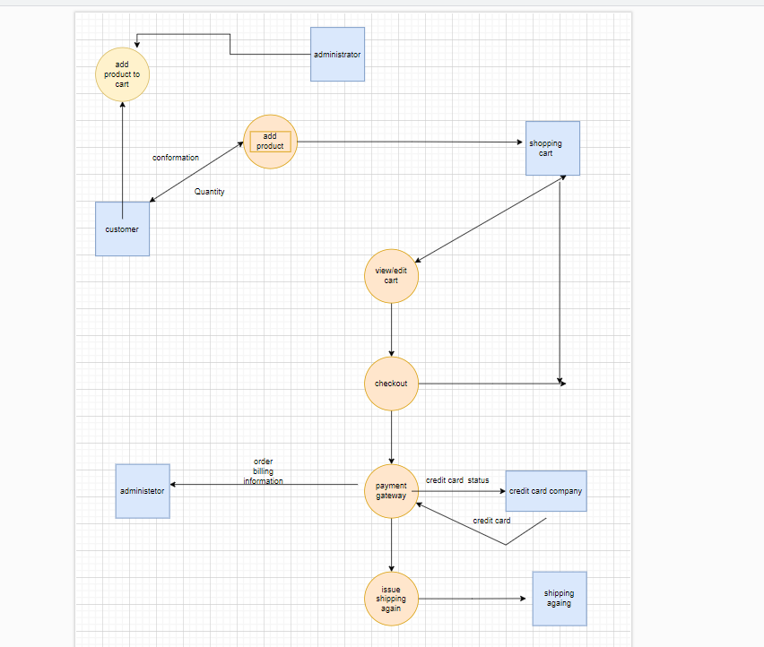

Q.5 :-what is flow chat ,make flow chat that addition two num.

->A flowchart is a diagram that depicts a process, system or computer algorithm. They are widely used in multiple fields to document, study, plan, improve and communicate often complex processes in clear, easy-to-understand diagrams.

The following are the uses of a flowchart:

* It is a pictorial representation of an algorithm that increases the readability of the program.
* Complex programs can be drawn in a simple way using a flowchart.
* It helps team members get an insight into the process and use this knowledge to collect data, detect problems, develop software, etc.
* A flowchart is a basic step for designing a new process or adding extra features.
* Communication with other people becomes easy by drawing flowcharts and sharing them.

**Symbols**

1.**start & end**:-This box is of an oval shape which is used to indicate the start or end of the program. Every flowchart diagram has an oval shape that depicts the start of an algorithm and another oval shape that depicts the end of an algorithm. 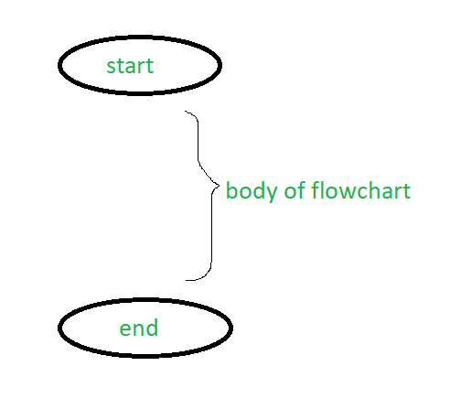

2)**data:**-This is a parallelogram-shaped box inside which the inputs or outputs are written. This basically depicts the information that is entering the system or algorithm and the information that is leaving the system or algorithm. For example: if the user wants to input a from the user and display it, the flowchart for this would be:

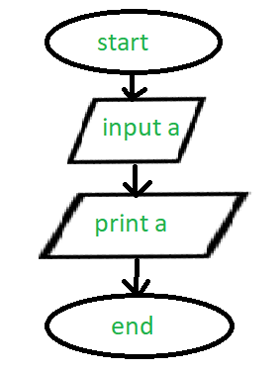



3).**process:-** This is a rectangular box inside which a programmer writes the main course of action of the algorithm or the main logic of the program. This is the crux of the flowchart as the main processing codes is written inside this box. For example:- if the programmer wants to add 1 to the input given by the user, he/she would make the following flowchart.

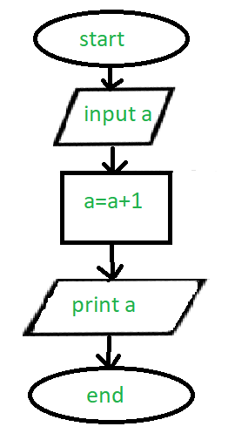



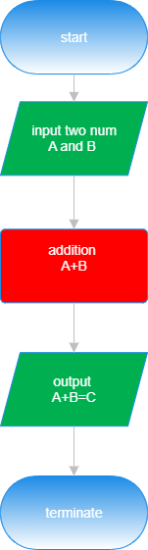

**Q.6-** what is use case diagram ?,make paytm diagram.

se-case diagrams describe the high-level functions and scope of a system. These diagrams also identify the interactions between the system and its actors. The use cases and actors in use-case diagrams describe what the system does and how the actors use it, but not how the system operates internally.



